PROJECT REPORT
Technical Project Report / Thesis

PlantDiseaseAI:
An Explainable Edge-AI and Hyperspectral-Reconstruction Framework for Grapevine and Tomato Disease Diagnosis with Multilingual Advisory

EfficientNet-B0 | Grad-CAM | Spectral Reconstruction | Raspberry Pi 5 | EN · HI · MR
Project title | PlantDiseaseAI (Edge-Compatible Plant Disease Detection and Hyperspectral Reconstruction with XAI)
Team / Group | XAI Plant-Disease (Sanket Dale)
Institution | Sanjivani University
Guide / Mentor | Dr. Arvind Mukundan
Crops covered | Grapevine (4 classes), Tomato (10 classes)
Document format | Academic report, IEEE-style numbering and references
Date | October 2026

Abstract
Foliar pathogens remain among the most consequential constraints on global crop production, yet field diagnosis is still dominated by subjective visual inspection and by "black-box" classifiers that return a label without justification. This report presents PlantDiseaseAI, an explainable, edge-deployable framework for grapevine and tomato disease diagnosis that unites three components: (i) two EfficientNet-B0 classifiers, a four-class grapevine model (224×224 input) and a ten-class tomato model (256×256 input), trained on the PlantVillage colour subset after perceptual-hash screening (Hamming distance ≤ 5) with a stratified 70:15:15 split (seed 42); (ii) Gradient-weighted Class Activation Mapping (Grad-CAM) computed on the final 1280-channel pointwise convolution, features[-1][0], and blended as a Jet overlay at α = 0.45; and (iii) a SpectrumTransfer module that reconstructs a continuous 401-band reflectance spectrum (380–780 nm, 1 nm step) from a single RGB image using a second-order polynomial colour expansion and six PCA components, calibrated with CIE colour-matching functions and the D65 illuminant.
On the held-out test sets the grapevine model reaches 99.18% accuracy (macro-F1 99.13%, N = 610) and the tomato model 98.42% accuracy (macro-F1 98.28%, N = 2,724). With Grad-CAM included, a single image is processed in 15.6 ms on a desktop CUDA GPU (64.1 FPS), 58.4 ms on a desktop CPU (17.1 FPS) and 161.3 ms on a Raspberry Pi 5 (6.2 FPS, 365 MB peak RAM). A PyQt6 application with dual viewports, rubber-band region-of-interest (ROI) selection, a live spectral graph, a 1.0×–8.0× gain control and a three-sheet openpyxl Excel export, together with a Raspberry Pi 5 / Camera Module 3 imaging chamber, turns the models into a complete field workstation. Disease names, organic remedies and chemical fungicides are provided in English, Hindi and Marathi using ICAR and MPKV (Rahuri) terminology. The result is an offline, low-cost diagnostic aid that shows the user not only what the model decided, but where on the leaf and in which spectral region the supporting evidence lies.
Keywords: plant disease diagnosis; EfficientNet-B0; Grad-CAM; explainable AI; hyperspectral reconstruction; PlantVillage; Raspberry Pi 5; edge computing; multilingual advisory; precision agriculture.

Table of Contents
Abstract1
Chapter 1: Introduction and Problem Statement3
1.1 Agricultural Significance of Grapevine and Tomato3
1.2 Challenges in Visual Crop Pathology3
1.3 Limitations of Traditional "Black-Box" CNNs3
1.4 Objectives3
1.5 Contributions and Novelty4
Chapter 2: Literature Review and Theoretical Foundation4
2.1 Evolution of Deep Learning in Phytopathology4
2.2 Explainable AI: CAM, Grad-CAM and Integrated Gradients4
2.3 Hyperspectral and Multispectral Imaging in Plant Stress Detection5
2.4 Edge Computing Platform5
2.5 Identified Gaps5
Chapter 3: Dataset Architecture and Preprocessing Pipeline5
3.1 Dataset Source and Statistics5
3.2 Perceptual-Hash Deduplication6
3.3 Class Imbalance Management6
3.4 Stratified 70:15:15 Partitioning7
3.5 Preprocessing and Data Augmentation7
Chapter 4: Deep Learning Model Architecture and Training7
4.1 EfficientNet-B0 Architecture7
4.2 Optimisation: AdamW, Cosine Annealing and Mixed Precision8
4.3 Training Configuration, Convergence and Early Stopping9
Chapter 5: Explainable AI (Grad-CAM) Mathematical Modeling10
5.1 Derivation of Grad-CAM10
5.2 Target Layer and Hook Implementation10
5.3 Normalisation, Jet Colormap and Alpha Blending11
5.4 Lesion-Focused versus Background-Focused Heatmaps11
5.5 Human-in-the-Loop Decision-Support Protocol12
Chapter 6: Reconstructed Hyperspectral Imaging and Spectral Transfer12
6.1 Problem Formulation12
6.2 PCA Spectral Basis and Polynomial Colour Expansion12
6.3 Colorimetric Calibration: CIE Colour-Matching Functions and D6513
6.4 Spectral Regions and Narrow-Band Views13
6.5 Comparative Spectral Signatures: Healthy versus Infected Leaves14
Chapter 7: System Architecture and Edge Deployment15
7.1 Modular Software Architecture15
7.2 Unified PyQt6 Desktop and Embedded GUI Workflow15
7.3 Platform Independence and Native PyTorch Model16
7.4 Multi-Sheet Excel Export Architecture (openpyxl)16
7.5 Raspberry Pi 5 and Camera Module 3 Laboratory Workstation17
Chapter 8: Experimental Results, Benchmarks and Discussion17
8.1 Evaluation Metrics17
8.2 Test-Set Classification Results18
8.3 Confusion Matrices18
8.4 Latency, Grad-CAM Overhead and Memory Profile20
8.5 Discussion20
Chapter 9: Multilingual Knowledge Base and Extensibility21
9.1 Trilingual Advisory Framework21
9.2 Organic versus Chemical Interventions21
9.3 Extensibility22
Chapter 10: Conclusion and Future Scope22
10.1 Summary of Contributions and Achievements22
10.2 Limitations23
10.3 Future Scope23
References24

Chapter 1: Introduction and Problem Statement

1.1 Agricultural Significance of Grapevine and Tomato
Grapevine (Vitis vinifera) and tomato (Solanum lycopersicum) are two of the most valuable horticultural crops in the world. Tomato is among the most widely grown vegetables, and its fruits feed both fresh-market and processing industries; grapevine supports table-grape, raisin and wine economies and is a high-input, high-value perennial. In India both crops are concentrated in a few states, with Maharashtra a leading producer of grapes (notably around Nashik, Sangli and Solapur) and a major tomato-growing state. Because the crops are capital-intensive, a single uncontrolled outbreak can erase the margin of a whole season.
Plant diseases caused by fungi, oomycetes, bacteria, viruses and mites reduce both yield and marketable quality in virtually every cropping system. A global assessment of pathogen and pest burdens on five major food crops estimated mean yield losses of roughly 17–30% depending on the crop [1]. Grapevine is affected by Black Rot (Guignardia bidwellii), by Esca (Black Measles), a trunk-disease complex whose foliar symptom is the characteristic "tiger-stripe" interveinal necrosis, and by leaf blight (Isariopsis leaf spot). Tomato is attacked by early blight, late blight, Septoria leaf spot, leaf mold, bacterial spot, target spot, spider-mite damage, Tomato Mosaic Virus (ToMV) and Tomato Yellow Leaf Curl Virus (TYLCV). Timely identification at the first appearance of symptoms largely determines whether an outbreak is contained by one intervention or spreads across an entire plot.

1.2 Challenges in Visual Crop Pathology
Field diagnosis is traditionally performed by an agronomist or by the grower’s own judgement. This practice suffers from five structural problems. (1) Scarcity of expertise: extension officers are few relative to the number of farms. (2) Subjectivity: early symptoms of different diseases (for example the concentric lesions of early blight and target spot, or the necrotic spots of Black Rot and leaf blight) are visually similar and are routinely confused. (3) Late detection: many physiological changes, such as chlorophyll degradation and loss of mesophyll structure, precede visible symptoms but are averaged away by an ordinary three-channel camera. (4) Language: many growers read Hindi or Marathi rather than English, whereas most digital tools are English-only. (5) Connectivity: cloud-based tools are unusable in orchards with poor coverage.
An RGB sensor integrates the incident spectrum S(λ) against three sensitivity curves, c_{k} = ∫ S(λ) Q_{k}(λ) dλ for k ∈ {R, G, B}, so the infinitely many spectra that produce the same triplet (metamers) are indistinguishable, and diagnostic information confined to narrow bands is lost. Hyperspectral cameras recover that information but are expensive and bulky, which motivates software reconstruction of spectra from RGB (Chapter 6).

1.3 Limitations of Traditional "Black-Box" CNNs
Convolutional neural networks (CNNs) have reached very high accuracy on public leaf datasets [2], [3], but a bare softmax score gives an agronomist no basis for trust. A network can be right for the wrong reason: laboratory datasets contain systematic regularities (backdrop, illumination, the position of the leaf) that a network can exploit instead of the lesion itself. When such a model is moved to the field, accuracy collapses; Mohanty et al. reported a drop from 99.35% to about 31% on images from different conditions [3]. A deployable system must therefore expose its evidence so that a human can accept or reject the decision, and must run on affordable hardware without a network connection.

1.4 Objectives
The main objective is to build and evaluate an offline, explainable, edge-deployable plant disease diagnosis system that couples CNN classification with RGB-to-spectrum reconstruction. The specific objectives are:
- Train an EfficientNet-B0 classifier for grapevine (4 classes, 224×224) and another for tomato (10 classes, 256×256) with a reproducible, leakage-aware data pipeline.
- Generate Grad-CAM heatmaps from features[-1][0] (1280 channels) and overlay them with a Jet colormap at α = 0.45, with a human-in-the-loop interpretation protocol.
- Reconstruct a continuous 401-band spectrum (380–780 nm) from RGB using six PCA components and a second-order polynomial colour expansion, calibrated with CIE colour-matching functions and D65.
- Deliver a PyQt6 desktop/edge application with dual viewports, ROI selection, a live spectral graph, gain control and multi-sheet Excel export.
- Benchmark accuracy, latency and memory on a CUDA GPU, a desktop CPU and a Raspberry Pi 5.
- Provide trilingual (English, Hindi, Marathi) disease names and organic/chemical interventions based on ICAR and MPKV terminology.

1.5 Contributions and Novelty
The contributions of this work are: (a) a pair of compact (≈4.0 million-parameter) EfficientNet-B0 models with test accuracies of 99.18% (grape) and 98.42% (tomato); (b) an integrated XAI-plus-spectral pipeline, so that a user can compare where the network looked with where spectral contrast is strongest; (c) a documented protocol for classifying heatmaps as lesion-focused or background-focused; (d) a complete benchmark on three hardware tiers showing that Grad-CAM adds only 29–37% to inference time; (e) a laboratory imaging chamber and application that export results to a structured Excel workbook; and (f) a trilingual advisory knowledge base. The novelty lies in combining these elements in a single offline application rather than treating classification, explanation, spectral imaging and farmer-facing advice as separate tools.
The remainder of the report is organised as follows. Chapter 2 reviews the literature; Chapter 3 describes the dataset; Chapter 4 the model and training; Chapter 5 the Grad-CAM mathematics and interpretation protocol; Chapter 6 the hyperspectral reconstruction; Chapter 7 the software and hardware system; Chapter 8 the experimental results; Chapter 9 the multilingual knowledge base; and Chapter 10 concludes with future scope.

Chapter 2: Literature Review and Theoretical Foundation

2.1 Evolution of Deep Learning in Phytopathology
Deep learning entered plant pathology soon after AlexNet [7] demonstrated large-scale image classification. The PlantVillage repository [2] made tens of thousands of expert-labelled leaf photographs available, and Mohanty et al. [3] fine-tuned AlexNet and GoogLeNet on it, reporting 99.35% test accuracy on laboratory images while warning of poor transfer to field images. Ferentinos [8] reached 99.53% on 58 classes with VGG-type networks, and Too et al. [9] showed that fine-tuned DenseNets outperform several other architectures with fewer parameters. Efficiency-oriented backbones followed: MobileNetV2 [10] introduced inverted residual blocks with linear bottlenecks, and EfficientNet [5] obtained a better accuracy-per-computation trade-off through compound scaling, which makes the B0 variant attractive for CPU-only devices such as the Raspberry Pi.
Table 1: Evolution of CNN backbones used in plant-disease classification.
Model | Year | Key idea | Parameters (approx.) | Relevance to edge use
AlexNet [7] | 2012 | Deep CNN, ReLU, dropout | ≈60 M | Too large and slow
VGG-16 | 2014 | Stacked 3×3 convolutions | ≈138 M | High memory
GoogLeNet | 2015 | Inception modules | ≈6.8 M | Moderate
DenseNet [9] | 2017 | Dense connectivity | ≈8 M (121) | Memory-hungry activations
MobileNetV2 [10] | 2018 | Inverted residual, linear bottleneck | ≈3.5 M | Good
EfficientNet-B0 [5] | 2019 | Compound scaling, MBConv + SE | ≈4.0 M (backbone) | Best accuracy per MAC

2.2 Explainable AI: CAM, Grad-CAM and Integrated Gradients
Explainability methods differ in cost, resolution and faithfulness (Table 2). Saliency maps [11] back-propagate the class score to the input pixels; they are cheap but noisy. Class Activation Mapping (CAM) multiplies the last convolutional feature maps by the weights of a following global-average-pooling classifier, but requires that architecture. Grad-CAM [6] generalises CAM by using the gradient of the class score as the weight, so it works with any differentiable head and needs only one forward and one backward pass. Integrated Gradients [12] accumulate gradients along a path from a baseline and satisfy completeness, but need tens to hundreds of passes and a meaningful baseline. Score-CAM [13] avoids gradients by weighting activation maps with the model’s own score on masked inputs, but needs one forward pass per channel (1280 here). Grad-CAM is therefore the best compromise for CPU inference.
Table 2: Comparison of explainability methods for an edge CNN.
Method | Principle | Passes | Resolution | Limitation
Saliency [11] | |∂y^{c}/∂x| at input | 1 fwd + 1 bwd | Pixel | Noisy, edge-biased
CAM | Classifier-weighted feature maps | 1 fwd | 7×7 / 8×8 | Needs GAP-linear head
Grad-CAM [6] | Gradient-weighted activation map | 1 fwd + 1 bwd | 7×7 / 8×8, upsampled | Coarse localisation
Integrated Gradients [12] | Path integral from baseline | 20–300 fwd + bwd | Pixel | Baseline choice; costly
Score-CAM [13] | Score-weighted masks | C + 1 fwd (C = 1280) | 7×7 / 8×8, upsampled | Too slow on CPU

2.3 Hyperspectral and Multispectral Imaging in Plant Stress Detection
Healthy leaf reflectance follows a characteristic signature: strong absorption by chlorophylls and carotenoids in the blue (about 430–470 nm) and by chlorophyll a in the red (about 660–680 nm), a reflectance maximum near 550 nm that gives leaves their green colour, and an abrupt rise between roughly 690 and 750 nm, the red edge, produced by the transition from chlorophyll absorption to scattering at air–cell-wall interfaces in the mesophyll [14], [15]. Disease alters this signature in predictable ways: loss of chlorophyll raises red reflectance, destruction of the mesophyll lowers the near-infrared plateau, and the red edge flattens and shifts. Imaging sensors have therefore been proposed for early disease detection [4].
Hyperspectral cameras sample tens to hundreds of contiguous bands but cost orders of magnitude more than an RGB camera. A pragmatic alternative is spectral reconstruction from RGB: sparse-dictionary [16] and training-based [17] methods estimate the spectrum from a colour triplet by exploiting the strong correlation of natural reflectance spectra. The approach adopted here is the training-based variant: a low-order polynomial colour expansion followed by a PCA-derived linear projection (Chapter 6).

2.4 Edge Computing Platform
The Raspberry Pi 5 [18] is built around the Broadcom BCM2712 SoC with a quad-core 64-bit Arm Cortex-A76 CPU at up to 2.4 GHz, a VideoCore VII GPU, LPDDR4X memory and dual MIPI camera/display interfaces. Its A76 cores are substantially faster than the Pi 4’s A72 cores, which makes a four-million-parameter CNN practical on the CPU alone.

2.5 Identified Gaps
Existing work typically (i) reports accuracy without explanation; (ii) treats spectral imaging and deep-learning diagnosis as separate systems; (iii) assumes a GPU or the cloud; and (iv) provides English-only output without a farmer-oriented data record. PlantDiseaseAI addresses all four gaps in one offline application.

Chapter 3: Dataset Architecture and Preprocessing Pipeline

3.1 Dataset Source and Statistics
Both classifiers are trained on the colour subset of the PlantVillage repository [2], which provides expert-labelled, single-leaf photographs on a uniform laboratory background. The grapevine dataset contains 4,062 images in four classes and the tomato dataset 18,160 images in ten classes (Table 3, Figure 1). The imbalance is substantial: Tomato Mosaic Virus (373 images) is roughly 14 times rarer than Tomato Yellow Leaf Curl Virus (5,357 images), and the healthy grapevine class (423 images) is about one third the size of the largest diseased class.
Table 3: Class mapping, image counts and inverse-frequency class weights w_{c} = N / (C·n_{c}).
Crop | Class | Images | Share (%) | Weight w_{c}
Grapevine | Black Rot | 1,180 | 29.05 | 0.861
Grapevine | Esca (Black Measles) | 1,383 | 34.05 | 0.734
Grapevine | Leaf Blight | 1,076 | 26.49 | 0.944
Grapevine | Healthy | 423 | 10.41 | 2.401
Tomato | Bacterial Spot | 2,127 | 11.71 | 0.854
Tomato | Early Blight | 1,000 | 5.51 | 1.816
Tomato | Late Blight | 1,909 | 10.51 | 0.951
Tomato | Leaf Mold | 952 | 5.24 | 1.908
Tomato | Septoria Leaf Spot | 1,771 | 9.75 | 1.025
Tomato | Spider Mites | 1,676 | 9.23 | 1.084
Tomato | Target Spot | 1,404 | 7.73 | 1.293
Tomato | Tomato Yellow Leaf Curl Virus | 5,357 | 29.50 | 0.339
Tomato | Tomato Mosaic Virus | 373 | 2.05 | 4.869
Tomato | Healthy | 1,591 | 8.76 | 1.141
Total | Grapevine 4,062 | Tomato 18,160 | 22,222

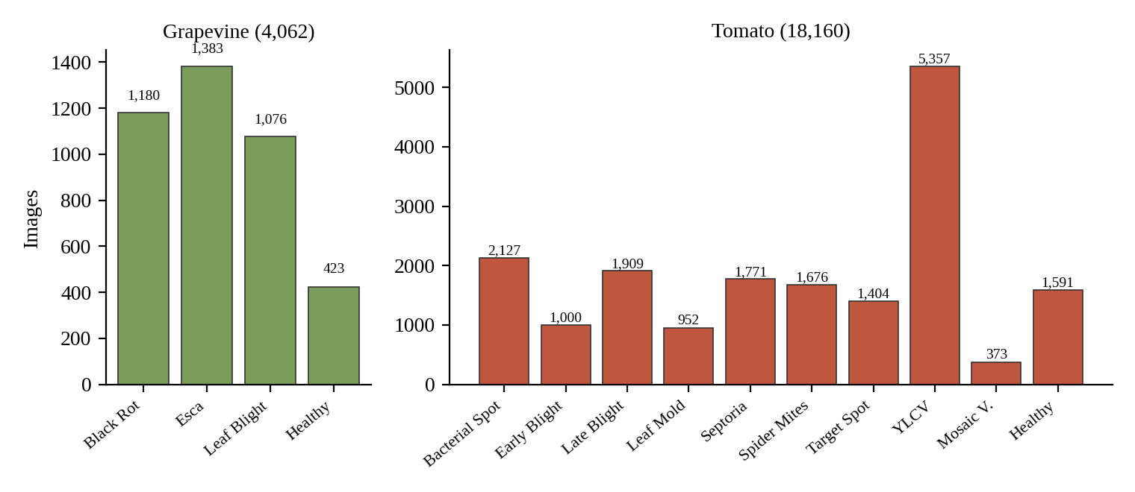
Figure 1: Class distribution of the grapevine (left) and tomato (right) datasets.

3.2 Perceptual-Hash Deduplication
PlantVillage contains many near-identical photographs of the same leaf taken from slightly different positions, and several images derived from one another by cropping or rotation. If such near-duplicates fall in different partitions, the test accuracy is inflated by memorisation rather than generalisation. To guard against this, a perceptual hash (pHash) is computed for every image: the image is reduced to a 32×32 greyscale thumbnail, a two-dimensional discrete cosine transform is applied, and the low-frequency 8×8 block (excluding the DC term) is thresholded at its median to give a 64-bit fingerprint h. Two images are declared near-duplicates when the Hamming distance
d_{H}(h_{a}, h_{b}) = Σ_{i=1}⁶⁴ [ h_{a,i} ≠ h_{b,i} ] ≤ 5(3.1)
which tolerates small illumination, crop and compression changes while still separating genuinely different leaves. Because pHash captures global low-frequency structure, it is insensitive to JPEG noise and small rescalings, in contrast to cryptographic hashes that change completely with a single byte. The class counts in Table 3 are those of the final experimental datasets.

3.3 Class Imbalance Management
Three complementary measures counter imbalance. First, the stratified split (Section 3.4) preserves every class proportion in every partition, so that rare classes are represented in validation and test. Second, the training loss is a class-weighted cross-entropy with the inverse-frequency weights of Table 3,
ℒ = −(1/B) Σ_{i=1}^{B} w_{y(i)} · log p_{i, y(i)}(3.2)
where B is the mini-batch size, y(i) the true class of sample i and p the softmax probability. Weighting penalises errors on rare classes such as Tomato Mosaic Virus (w = 4.869) more heavily than on common classes such as TYLCV (w = 0.339). Third, evaluation reports macro-averaged precision, recall and F1, which treat all classes equally, in addition to overall accuracy.

3.4 Stratified 70:15:15 Partitioning
Each crop dataset is partitioned into training, validation and test subsets in the ratio 70:15:15 by stratified random sampling with a fixed random seed of 42, so that the split is exactly reproducible. The training set is used to fit weights, the validation set to select the stopping epoch, and the test set only for the final reported metrics.
Table 4: Stratified data partitions (seed = 42).
Crop | Total | Train (70%) | Validation (15%) | Test (15%)
Grapevine | 4,062 | 2,843 | 609 | 610
Tomato | 18,160 | 12,712 | 2,724 | 2,724

3.5 Preprocessing and Data Augmentation
Resizing and normalisation. Grapevine images are resized to 224×224×3 and tomato images to 256×256×3 with bilinear interpolation, in which the value at a non-integer source position (x + a, y + b), 0 ≤ a, b < 1, is a weighted mean of its four neighbours:
f(x+a, y+b) = (1−a)(1−b) f₀₀ + a(1−b) f₁₀ + (1−a)b f₀₁ + ab f₁₁(3.3)
Pixel values are then scaled to [0, 1] and standardised per channel with the ImageNet statistics [19] used to pre-train the backbone, μ = (0.485, 0.456, 0.406) and σ = (0.229, 0.224, 0.225):
x′_{c} = ( x_{c} / 255 − μ_{c} ) / σ_{c}, c ∈ {R, G, B}(3.4)
Augmentation. To improve robustness to orientation, pose and illumination, the following transformations are applied to training images only; validation and test images receive only resizing and normalisation.
Table 5: Training-time augmentation pipeline.
Transform | Setting | Purpose
RandomHorizontalFlip | p = 0.5 | Leaf orientation invariance
RandomVerticalFlip | p = 0.2 | Pose invariance (less frequent)
RandomRotation | ± 15° | Camera roll
RandomAffine | shear ± 5°, scale 0.95–1.05 | Perspective and distance variation
ColorJitter | brightness 0.15, contrast 0.15, saturation 0.10, hue 0.05 | Illumination and white-balance variation

The colour-jitter ranges are deliberately small (hue ± 0.05, saturation ± 0.10) because colour is itself diagnostic: chlorosis and necrosis are defined by colour change, so aggressive hue shifts could turn a healthy leaf into an apparently diseased one.

Chapter 4: Deep Learning Model Architecture and Training

4.1 EfficientNet-B0 Architecture
EfficientNet [5] scales network depth d, width w and input resolution r together with a single compound coefficient φ:
d = α^{φ}, w = β^{φ}, r = γ^{φ}, subject to α·β²·γ² ≈ 2, α, β, γ ≥ 1(4.1)
The baseline B0 (φ = 0) uses α = 1.2, β = 1.1, γ = 1.15 and is built from mobile inverted bottleneck (MBConv) blocks [10]. Each block (i) expands the channels with a 1×1 convolution (expansion ratio 1 or 6), (ii) applies a k×k depthwise convolution, (iii) passes the result through a squeeze-and-excitation (SE) unit [20], (iv) projects back with a linear 1×1 convolution and (v) adds a residual connection when input and output shapes match. A depthwise-separable convolution reduces the cost of a k×k convolution with C_{out} output channels to roughly (1/C_{out} + 1/k²) of a standard convolution, which is the main source of B0’s efficiency.
Squeeze-and-Excitation. The SE unit recalibrates channels using global context. With z the global-average-pooled descriptor of the expanded feature map x,
s = σ( W₂ · SiLU( W₁ z ) ), x̃_{c} = s_{c} · x_{c}(4.2)
where σ is the sigmoid and W₁, W₂ are two small fully connected layers (reduction ratio 4 relative to the block input channels). Swish/SiLU activation. Throughout the network the activation is the Sigmoid Linear Unit [21],
SiLU(x) = x · σ(x) = x / (1 + e^{−*x*})(4.3)
which is smooth and non-monotonic and has been found to outperform ReLU in deep mobile networks. The layer structure (torchvision indexing) is given in Table 6.
Table 6: EfficientNet-B0 layer structure and the Grad-CAM target layer.
features[i] | Operator | Kernel | Channels | Layers
0 | Conv + BN + SiLU (stem, stride 2) | 3×3 | 32 | 1
1 | MBConv1 (SE) | 3×3 | 16 | 1
2 | MBConv6 (SE) | 3×3 | 24 | 2
3 | MBConv6 (SE) | 5×5 | 40 | 2
4 | MBConv6 (SE) | 3×3 | 80 | 3
5 | MBConv6 (SE) | 5×5 | 112 | 3
6 | MBConv6 (SE) | 5×5 | 192 | 4
7 | MBConv6 (SE) | 3×3 | 320 | 1
8 = features[-1] | [0] 1×1 Conv 320→1280 (Grad-CAM target), then BN, SiLU | 1×1 | 1280 | 1
Head | Global average pool, Dropout, Linear(1280→C) | – | C = 4 / 10 | –

The 4,007,548-parameter backbone is shared by both models; the classification head adds 1280·C + C parameters, giving 4,012,672 parameters for the grapevine model (C = 4) and 4,020,358 for the tomato model (C = 10), about 16 MB in FP32. The forward cost is about 0.39 G multiply-accumulates (MACs) at 224×224 and about 0.51 G MACs at 256×256, scaling with pixel count. The 1000-way ImageNet head is discarded and replaced by a new linear layer with 4 outputs (grapevine) or 10 outputs (tomato); all layers are fine-tuned.

4.2 Optimisation: AdamW, Cosine Annealing and Mixed Precision
AdamW. Weights are optimised with AdamW, which decouples weight decay from the adaptive gradient update [28]. With gradient g_{t} = ∇_{θ}ℒ_{t}, the update at step t is
m_{t} = β₁ m_{t−1} + (1 − β₁) g_{t}, v_{t} = β₂ v_{t−1} + (1 − β₂) g_{t}²(4.4)
m̂_{t} = m_{t} / (1 − β₁^{t}), v̂_{t} = v_{t} / (1 − β₂^{t})(4.5)
θ_{t} = θ_{t−1} − η_{t} ( m̂_{t} / (√v̂_{t} + ε) + λ θ_{t−1} )(4.6)
with β₁ = 0.9, β₂ = 0.999, ε = 10⁻⁸ and weight decay λ = 10⁻⁴. Because the decay term λθ acts directly on the weights rather than being added to the gradient, it is not rescaled by the adaptive denominator, which improves generalisation compared with L2-regularised Adam.
Cosine annealing with warm-up. The learning rate rises linearly to its peak η_{max} = 10⁻³ over the warm-up period of t_{w} = 2 epochs (grapevine) and then decays to η_{min} = 10⁻⁵ along a half-cosine [22] over the remaining epochs of the maximum horizon T = 50:
η_{t} = η_{max} · (t + 1) / t_{w} for t < t_{w}(4.7)
η_{t} = η_{min} + ½ (η_{max} − η_{min}) [ 1 + cos( π (t − t_{w}) / (T − t_{w}) ) ] for t ≥ t_{w}(4.8)
Warm-up prevents large, destabilising updates while the new classification head and the Adam moment estimates are still uninformative; the cosine tail then supplies large steps for fast early progress and decays smoothly to a small rate that stabilises the final fine-tuning phase (Figure 2). A warm-up length is specified for the grapevine run only; the tomato run uses the same peak and minimum rates.
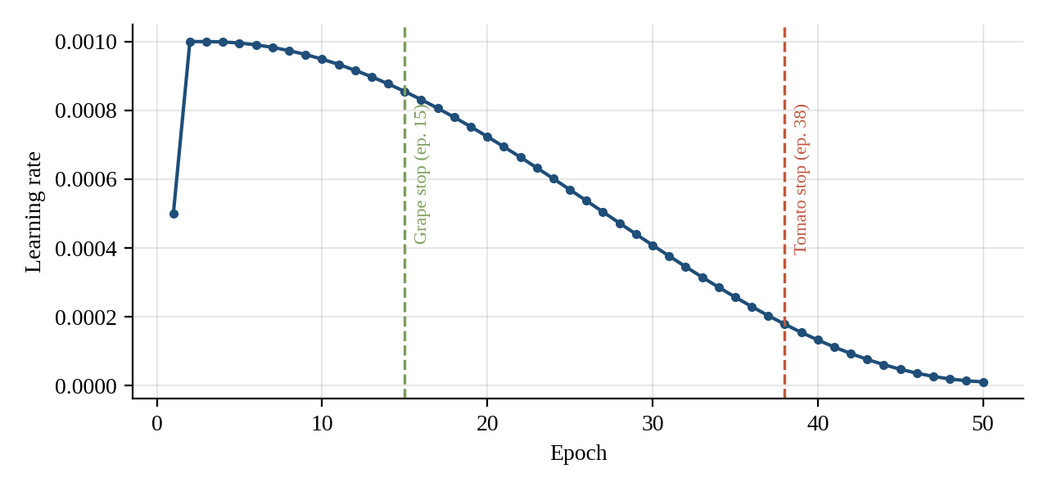
Figure 2: Cosine-annealing schedule (η_{max} = 10⁻³, η_{min} = 10⁻⁵, T = 50, two-epoch warm-up) computed from Eqs. 4.7–4.8, with the epochs at which early stopping terminated each run.
Mixed precision. Forward and backward passes run under PyTorch automatic mixed precision (AMP) in FP16 with a dynamic GradScaler [29]. Because FP16 has a narrow exponent range, small gradients can underflow to zero; the loss is therefore multiplied by a scale factor S before back-propagation, and the gradients are divided by S before the optimiser step:
g_{t} = (1/S) ∇_{θ}( S · ℒ_{t} )(4.9)
If any gradient is infinite or NaN, the step is skipped and S is reduced; after a run of successful steps S is increased. Master weights and the AdamW moments are kept in FP32. Mixed precision roughly halves activation memory and speeds up training on tensor-core GPUs with negligible accuracy loss.
Gradient clipping. After unscaling, the global gradient norm is clipped to c = 1.0 [30]:
g ← g · min( 1, c / ‖g‖₂ )(4.10)
which bounds the update size when a mini-batch produces an unusually large gradient, for example at the first iterations after warm-up or on rare, heavily weighted classes.

4.3 Training Configuration, Convergence and Early Stopping
Table 7: Training configuration (both models unless stated).
Item | Grapevine | Tomato
Backbone / initialisation | EfficientNet-B0, ImageNet pre-trained | EfficientNet-B0, ImageNet pre-trained
Output classes | 4 | 10
Input resolution | 224×224×3 | 256×256×3
Train / val / test images | 2,843 / 609 / 610 | 12,712 / 2,724 / 2,724
Optimiser | AdamW (β₁=0.9, β₂=0.999, ε=10⁻⁸, λ=10⁻⁴) | AdamW (same)
Learning rate | Peak 10⁻³, min 10⁻⁵, cosine; 2-epoch warm-up | Peak 10⁻³, min 10⁻⁵, cosine
Batch size / max epochs | 32 / 50 | 32 / 50
Precision | AMP FP16 + GradScaler | AMP FP16 + GradScaler
Gradient clipping | max_norm = 1.0 | max_norm = 1.0
Early-stopping patience | 10 epochs | 8 epochs
Stopped at epoch | 15 | 38
Validation loss at stop | 0.000447 | 0.000670
Validation accuracy at stop | 100% | 100%

With a batch size of 32 and no dropped batches, one epoch comprises ⌈2,843/32⌉ = 89 iterations for the grapevine model and ⌈12,712/32⌉ = 398 iterations for the tomato model, so training ended after about 1,335 and 15,124 weight updates respectively. Early stopping monitors the validation loss and halts when it has not improved for p consecutive epochs (p = 10 for grapevine, p = 8 for tomato), restoring the best checkpoint. Stopping at epoch 15 with p = 10 implies that the best grapevine checkpoint was recorded at epoch 5; stopping at epoch 38 with p = 8 implies a best tomato checkpoint at epoch 30, provided the patience counter is reset only by an improvement.
Both models converged to a validation loss below 10⁻³ and 100% validation accuracy (609 and 2,724 images respectively). Two observations deserve emphasis. First, the grapevine model converges roughly 2.5 times faster in epochs than the tomato model, consistent with its smaller dataset (2,843 vs. 12,712 training images) and fewer, more visually separable classes. Second, validation accuracy is saturated: a 100% score cannot discriminate between checkpoints, which is why the validation loss rather than accuracy drives early stopping, and why the independent test set (Chapter 8) is the only unbiased estimate of generalisation.

Chapter 5: Explainable AI (Grad-CAM) Mathematical Modeling

5.1 Derivation of Grad-CAM
Let y^{c} be the pre-softmax logit for class c and let A^{k} ∈ ℝ^{u×v} be the k-th channel of a convolutional feature map, with Z = u·v spatial positions. Class Activation Mapping applies to networks whose head is a global average pool (GAP) followed directly by a linear layer with weights w^{c}_{k}:
y^{c} = Σ_{k} w^{c}_{k} · (1/Z) Σ_{i} Σ_{j} A^{k}_{ij}(5.1)
Differentiating with respect to a single activation gives ∂y^{c}/∂A^{k}_{ij} = w^{c}_{k}/Z, so averaging the gradient over all positions (a further factor Z/Z) recovers the CAM weight up to the constant 1/Z, which disappears under normalisation. Grad-CAM [6] therefore defines the channel importance for an arbitrary differentiable head as the spatially averaged gradient:
α^{c}_{k} = (1/Z) Σ_{i} Σ_{j} ∂y^{c} / ∂A^{k}_{ij}(5.2)
L^{c}_{Grad-CAM} = ReLU( Σ_{k=1}¹²⁸⁰ α^{c}_{k} A^{k} )(5.3)
The ReLU keeps only features with a positive influence on the class of interest; negative regions mostly belong to competing classes. Gradients are taken with respect to the logit rather than the softmax probability, because the softmax saturates when the model is confident and would yield vanishing gradients exactly when the explanation matters most.

5.2 Target Layer and Hook Implementation
The target layer is features[-1][0], the 1×1 pointwise convolution that expands 320 channels to 1280 at the end of the backbone. It is the deepest layer that still has a spatial grid (7×7 for 224×224 grapevine input and 8×8 for 256×256 tomato input, because the total stride is 32), so its channels encode the most semantic features while preserving lesion location; the global pooling and linear layers that follow have no spatial structure. Note that this hook captures the convolution output before the batch normalisation and SiLU that complete the block, so the map is linear in the preceding features and the ReLU in Eq. 5.3 supplies the rectification.
Two hooks are registered on this module: a forward hook stores the activation tensor A ∈ ℝ^{1×1280×u×v}, and a backward hook stores the gradient ∂y^{c}/∂A. A single forward pass produces the prediction, a single backward pass from the selected logit produces all gradients, and Eqs. 5.2–5.3 are evaluated on the stored tensors (Figure 3).
Input image I --> resize --> normalise --> x
|
+-----------------------v------------------------+
| EfficientNet-B0 features[0] ... features[-1] |
| [0] 1x1 Conv 320->1280 |<-- forward hook : A (1280 x u x v)
| BN + SiLU |
+-----------------------+------------------------+
v
GAP -> Dropout -> Linear -> logits y
| pick class c = argmax(y)
v
y^c.backward() ----------------------> backward hook : dy^c/dA

alpha_k = mean_ij( dy^c/dA_k ) (1280 channel weights)
L = ReLU( sum_k alpha_k * A_k ) (u x v map: 7x7 or 8x8)
L~ = (L - min L) / (max L - min L + eps)
H = Jet( upsample_bilinear(L~) to input size )
O = (1 - 0.45) * I + 0.45 * H --> overlay shown in the GUI

Figure 3: Grad-CAM data flow with forward and backward hooks on features[-1][0].

5.3 Normalisation, Jet Colormap and Alpha Blending
The coarse map is min–max normalised, upsampled bilinearly to the input size, mapped through the Jet colormap and alpha-blended with the original image I:
L̃ = ( L − min L ) / ( max L − min L + ε )(5.4)
H(x, y) = Jet( L̃(x, y) )(5.5)
O = (1 − α) · I + α · H, α = 0.45(5.6)
The Jet colormap maps the scalar t ∈ [0, 1] to colour through three piece-wise linear channels,
R(t) = clip( min(4t − 1.5, −4t + 4.5), 0, 1 ), G(t) = clip( min(4t − 0.5, −4t + 3.5), 0, 1 ), B(t) = clip( min(4t + 0.5, −4t + 2.5), 0, 1 )(5.7)
so that t = 0 appears dark blue (lowest contribution), t ≈ 0.5 green, and t = 1 dark red (highest contribution to the predicted class). With α = 0.45 the heatmap is clearly visible while leaf texture and lesion edges remain legible; a larger α hides the lesion, a smaller one hides the heatmap. Normalisation is per image, so colours express relative importance within one leaf, not absolute confidence; the confidence is reported separately by the classifier.

5.4 Lesion-Focused versus Background-Focused Heatmaps
A model that is accurate for the wrong reasons is exposed by comparing the heatmap with the visible pathology. Each heatmap is judged as lesion-focused when its high-activation (red/yellow) region overlaps the visible symptom, or background-focused when it concentrates on non-leaf structures or on leaf-independent artefacts.
Lesion-focused behaviour. A correctly localised heatmap should follow the pathological anatomy of each disease (Table 8). For example, in Black Rot the activation should concentrate on the tan-brown necrotic centre and its dark margin, where pycnidia appear as tiny black dots; in Esca on the interveinal "tiger-stripe" necrosis bounded by the veins; in tomato early blight on the concentric-ringed necrotic spots; in late blight on the water-soaked, greasy-looking lesions at the leaf margin; and in TYLCV on the curled, yellowed leaf blade rather than on any discrete spot, because the symptom is systemic. Systemic or diffuse diseases (mosaic, TYLCV, spider-mite stippling) legitimately produce broad, low-contrast heatmaps, which should not be mistaken for background focus.
Table 8: Expected lesion localisation by disease (pathological basis of heatmap review).
Class | Characteristic foliar symptom | Expected Grad-CAM focus
Grape Black Rot | Tan–brown circular necrotic spots with dark margin; black pycnidia | Necrotic centre and margin of each spot
Grape Esca | Interveinal "tiger-stripe" chlorosis/necrosis | Interveinal bands
Grape Leaf Blight | Irregular dark-brown blotches, often at margins | Blotch area
Tomato Early Blight | Dark spots with concentric rings, yellow halo | Ringed lesion
Tomato Late Blight | Water-soaked, greasy, spreading lesions | Lesion front and margin
Tomato Septoria | Many small circular spots, grey centre, dark border | Cluster of spots
Tomato Leaf Mold | Pale-yellow patches on upper surface | Yellow patches
Tomato Bacterial Spot / Target Spot | Small dark water-soaked spots / targets with halos | Spot area
Tomato Spider Mites | Stippling, bronzing, fine webbing | Diffuse leaf blade
Tomato TYLCV / ToMV | Curling, yellowing, stunting / mottled mosaic | Diffuse blade, no single spot

Background-focused artefacts. The failure modes that matter most in practice are confounders correlated with the label in the training data or introduced by careless acquisition: (i) fingers and hands holding the leaf, whose skin tones and positions can correlate with a class if one session was photographed hand-held; (ii) specular glare, which saturates pixels and mimics a pale lesion; (iii) the bench, tray or backdrop, whose colour and texture are constant within a collection session; (iv) cast shadows and the leaf border, which create strong edges. When the red region sits on such structures, the prediction may still be correct on the test set but is not trustworthy in the field, because the cue will be absent or different there. PlantVillage itself is photographed on a uniform grey/black laboratory background, which makes background shortcuts possible and is one reason heatmap review is essential before deploying a laboratory-trained model in the field.
For a quantitative treatment, two statistics can be defined for a test image with leaf mask M_{leaf} and annotated lesion mask M_{les}: the lesion-overlap ratio and the background energy fraction,
LOR = Σ L̃ · M_{les} / Σ L̃, BEF = Σ L̃ · (1 − M_{leaf}) / Σ L̃(5.8)
A faithful model should show a high LOR and a BEF close to zero. These statistics define the proposed evaluation protocol for the heatmaps; the results reported in this work are the classification and efficiency measurements of Chapter 8, and a lesion-annotated subset would be required to report LOR and BEF.

5.5 Human-in-the-Loop Decision-Support Protocol
Grad-CAM is used as a decision-support tool, not as an autonomous diagnosis. The field protocol for agronomists is:
- Acquire a single leaf in the imaging chamber or against a plain background, avoiding hands, glare and shadows (Chapter 7).
- Read the prediction and its confidence together with the Grad-CAM overlay.
- Classify the heatmap as lesion-focused, diffuse-but-appropriate (systemic disease) or background-focused (Table 9).
- Cross-check with the reconstructed spectral view (Chapter 6): a diagnosis of a necrotic disease should be accompanied by raised red and depressed near-infrared reflectance in the ROI.
- Decide: accept the result and open the advisory, re-acquire the image, or escalate to an expert or laboratory test.
- Record the decision in the Excel export so that outcomes can later be audited.
Table 9: Decision matrix combining heatmap type and confidence.
Heatmap type | Confidence high | Confidence low
Lesion-focused | Accept; show advisory | Re-image; consider second opinion
Diffuse, appropriate for systemic disease | Accept with spectral confirmation | Escalate to expert
Background-focused (fingers, glare, bench) | Reject; re-acquire image (possible shortcut) | Reject; re-acquire image

Chapter 6: Reconstructed Hyperspectral Imaging and Spectral Transfer

6.1 Problem Formulation
An RGB camera with spectral sensitivities Q_{k}(λ) under illuminant D(λ) records, for a surface of reflectance R(λ), the triplet c_{k} = ∫ D(λ) R(λ) Q_{k}(λ) dλ. The goal of SpectrumTransfer is to invert this mapping statistically: to estimate, for every pixel, the spectrum S(λ) at 1 nm steps from 380 to 780 nm (401 continuous bands) from the three measured values. The inversion is under-determined (3 measurements, 401 unknowns), but natural reflectance spectra are smooth and highly correlated, so they lie close to a low-dimensional subspace that can be learned from data.

6.2 PCA Spectral Basis and Polynomial Colour Expansion
Principal Component Analysis (PCA) [23] of a training set of spectra yields a mean spectrum c̄ ∈ ℝ⁴⁰¹ and an eigenvector matrix P ∈ ℝ^{6×401}, whose rows are the six leading eigenvectors of the spectral covariance matrix (covering 380–780 nm at 1 nm). Any spectrum is approximated by
S(λ) ≈ c̄(λ) + Σ_{j=1}⁶ z_{j} p_{j}(λ) ⇔ S = c̄ + P^{T} z, z ∈ ℝ⁶(6.1)
Six components are sufficient because reflectance spectra of natural materials are dominated by a few smooth modes; the remaining variance is largely sensor noise. The linear RGB triplet is lifted into a second-order polynomial feature vector, which captures the non-linear colour–spectrum relation that a plain three-term linear map cannot:
v_{color} = [ R, G, B, R², G², B² ]^{T} ∈ ℝ⁶(6.2)
A coefficient matrix M ∈ ℝ^{6×6} maps the colour features to the PCA coordinates, z = M v_{color}. M is estimated by (ridge-regularised) least squares between the colour features and the PCA coordinates of a training set of n paired samples: M = argmin Σ_{n} ‖ z_{n} − M v_{n} ‖² + ρ‖M‖_{F}². Substituting into Eq. 6.1 and writing the spectrum as a row vector gives the SpectrumTransfer transformation:
S(λ) = v_{color}^{T} · ( M^{T} P ) + c̄(λ)(6.3)
Because M^{T}P ∈ ℝ^{6×401} and c̄ are constants, they are pre-multiplied once and stored, so reconstruction costs one 6×401 matrix–vector product per pixel (2,406 multiply-accumulates). For a 224×224 image this is about 1.2×10⁸ MACs, i.e. on the order of one third of the cost of the CNN forward pass, which is efficient enough for CPU and Raspberry Pi use. The mapping is a statistical estimate: it is accurate to the extent that the imaged leaves resemble the spectra and illumination of the training data, and it cannot recover information that the RGB sensor never recorded.
RGB pixel (R,G,B) in [0,1]
|
v polynomial expansion
v = [R, G, B, R^2, G^2, B^2] (6 x 1)
|
v z = M v (M: 6 x 6, least squares)
z = [z1 ... z6] (6 PCA coordinates)
|
v S = c_mean + P^T z (P: 6 x 401 eigenvectors)
S(380), S(381), ... , S(780) (401 bands, 1 nm step)
|
+--> spectral graph (ROI mean) +--> CMF/D65 calibration --> RGB check

Figure 4: SpectrumTransfer pipeline from one RGB pixel to a 401-band spectrum.

6.3 Colorimetric Calibration: CIE Colour-Matching Functions and D65
To render and verify the spectrum on a standard display, the reconstruction is calibrated colorimetrically using three data files: CR_cmf.txt, the CIE 1931 colour-matching functions x̄(λ), ȳ(λ), z̄(λ) [24] sampled at 1 nm from 380 to 780 nm; CR_light.txt, the relative spectral power distribution D(λ) of the CIE D65 daylight illuminant; and CR_ma.txt, a 3×3 colour matrix M_{a} that converts tristimulus values to linear display RGB. The tristimulus values of a reconstructed spectrum are
[ X, Y, Z ] = k Σ_{λ=380}⁷⁸⁰ S(λ) D(λ) [ x̄(λ), ȳ(λ), z̄(λ) ] Δλ, k = 100 / Σ_{λ} D(λ) ȳ(λ) Δλ(6.4)
[ R, G, B ]^{T}_{lin} = M_{a} [ X, Y, Z ]^{T}(6.5)
The constant k scales Y to 100 for a perfect white reflector. Together, Eqs. 6.4–6.5 allow a round-trip consistency check: the reconstructed spectrum is projected back to RGB and compared with the captured pixel (for example by a CIELAB colour difference ΔE), which verifies the internal consistency of the calibration. When the capture illuminant differs from D65 (the imaging chamber of Chapter 7 uses a 5000 K source), a Bradford chromatic-adaptation transform M_{adapt} = M_{A}⁻¹ diag(ρ_{D}/ρ_{S}, γ_{D}/γ_{S}, β_{D}/β_{S}) M_{A}, with [ρ, γ, β]^{T} = M_{A}[X, Y, Z]^{T} the cone-like responses of the source (S) and destination (D) white points, can be applied before Eq. 6.5 [25].

6.4 Spectral Regions and Narrow-Band Views
Mean reconstructed intensities over wavelength sets Λ_{b}, I_{b} = (1/|Λ_{b}|) Σ_{λ ∈ b} S(λ), are displayed as narrow-band images scaled by the user gain g ∈ [1.0, 8.0], I′_{b} = clip(g·I_{b}, 0, 1). Gain acts on the visualisation path only, so adjusting the slider never alters the classifier input or the diagnosis. Table 10 lists the spectral regions used in the analysis and their physiological meaning.
Table 10: Spectral regions and their physiological interpretation in leaf tissue.
Region | Wavelengths (nm) | Physiological basis | Expected effect of infection
Blue | ≈ 400–450 | Strong chlorophyll and carotenoid absorption | Pigment loss slightly raises reflectance; necrotic spots gain contrast
Green | ≈ 500–570 | Reflectance maximum near 550 nm | Green peak is lowered or flattened
Red | ≈ 620–700 | Chlorophyll a absorption trough near 670 nm | Reflectance rises as chlorophyll is degraded (chlorosis, necrosis)
Red-edge | ≈ 700–750 | Transition set by mesophyll scattering | Edge flattens and shifts
NIR (shoulder) | ≈ 750–780 | Plateau governed by leaf internal structure | Falls when the mesophyll collapses

6.5 Comparative Spectral Signatures: Healthy versus Infected Leaves
Figure 5 and Table 11 compare the reconstructed signatures of healthy and infected leaf tissue at the three diagnostic wavelengths. Healthy tissue shows the classic pattern: a green peak at 550 nm of 24.8% reflectance, a deep chlorophyll absorption dip at 670 nm of 8.2%, and a near-infrared plateau at 750 nm of 53.4%. In infected tissue with collapsed mesophyll the plateau at 750 nm drops to 24.1%, while reflectance at 670 nm rises to 27.4% because chlorophyll has been degraded and less red light is absorbed.
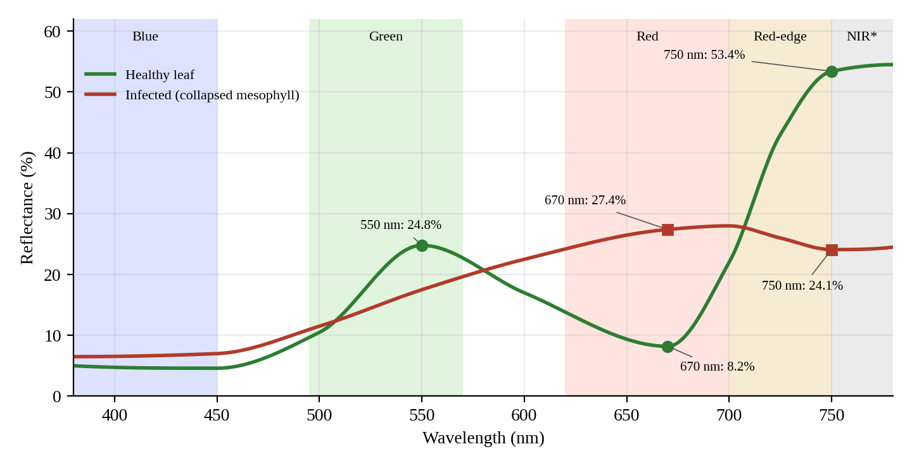
Figure 5: Healthy versus infected leaf reflectance, 380–780 nm. Markers show the reported values at 550, 670 and 750 nm; the curve shape between markers is illustrative. *NIR here denotes the shoulder at the upper end of the 380–780 nm reconstruction range.
Table 11: Reconstructed reflectance at diagnostic wavelengths (%).
Wavelength | Spectral region | Healthy | Infected | Change
550 nm | Green peak | 24.8 | Lowered (qualitative) | Green peak attenuated
670 nm | Red / chlorophyll dip | 8.2 | 27.4 | +19.2 points (×3.3)
750 nm | Red-edge / NIR shoulder | 53.4 | 24.1 | −29.3 points (−54.9%)

Two derived quantities summarise the contrast. The red-edge ratio R₇₅₀/R₆₇₀ is 53.4/8.2 = 6.5 for healthy tissue but 24.1/27.4 = 0.88 for infected tissue, and a narrow-band vegetation index
NDVI_{nb} = ( R₇₅₀ − R₆₇₀ ) / ( R₇₅₀ + R₆₇₀ )(6.6)
falls from (53.4 − 8.2)/(53.4 + 8.2) = 0.73 for healthy tissue to (24.1 − 27.4)/(24.1 + 27.4) = −0.06 for infected tissue. The collapse of both the red contrast and the near-infrared plateau therefore provides a spectral confirmation channel that is independent of the CNN: the network judges texture and colour pattern, whereas the spectrum reflects pigment and structural state. Agreement between the two strengthens a diagnosis; disagreement flags the image for review under the protocol of Section 5.5.
Caveat. The spectrum is reconstructed from three colour channels, not measured. Values beyond the visible range, in particular the red-edge and NIR shoulder, are statistical extrapolations that rely on the correlation between visible colour and the underlying spectral shape; they should be validated against a spectroradiometer before any quantitative biophysical use.

Chapter 7: System Architecture and Edge Deployment

7.1 Modular Software Architecture
Figure 6 shows the modular architecture. Frames from a Raspberry Pi camera, a USB webcam or an image file enter a preprocessing stage and fan out to three engines that share the same tensor: the prediction engine (EfficientNet-B0), the XAI engine (Grad-CAM) and the spectral engine (SpectrumTransfer). Their outputs converge on the decision, visualisation and ROI-analysis components, which are displayed by the PyQt6 GUI and exported by an openpyxl writer. Hardware access is isolated in a driver layer, so no model or UI code contains platform-specific camera calls.
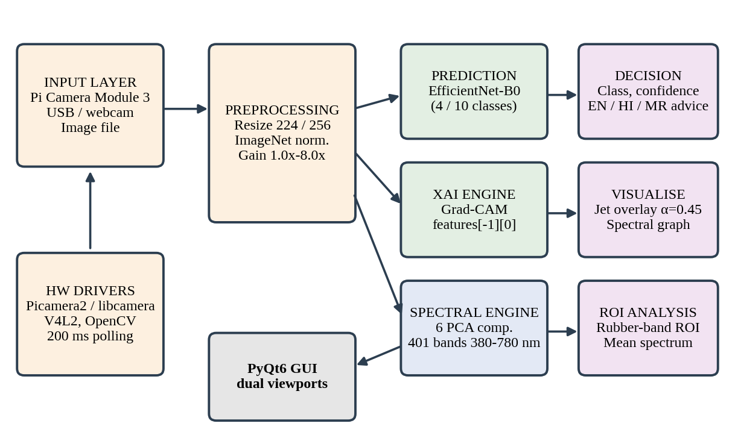
Figure 6: Modular system architecture of PlantDiseaseAI.
Table 12: Software modules and responsibilities.
Module | Responsibility
Prediction engine | Loads the crop-specific checkpoint, runs the EfficientNet-B0 forward pass, returns softmax probabilities and the top-1 class.
XAI engine | Registers forward/backward hooks on features[-1][0]; computes Grad-CAM, applies the Jet colormap and α = 0.45 blending.
Spectral engine | Six-term colour expansion, PCA projection to 401 bands, CMF/D65 calibration, band averaging and gain scaling.
Localisation / ROI | Maps the rubber-band box to image coordinates; computes class evidence and mean spectrum inside the ROI.
UI layer | PyQt6 windows, dual viewports, live Matplotlib spectral graph, gain slider, language switch, touch-friendly layouts.
Export layer | openpyxl writer producing the three-sheet workbook (Section 7.4).
Hardware drivers | Platform detection; Picamera2/libcamera and V4L2 on Linux, OpenCV DirectShow on Windows; OpenCV fallback.

7.2 Unified PyQt6 Desktop and Embedded GUI Workflow
A single PyQt6 code base serves the Windows desktop and the Raspberry Pi touch display. The main window contains dual live image viewports: the left viewport shows the captured or loaded leaf (optionally with the Grad-CAM overlay), and the right viewport shows the reconstructed spectral image for the selected band. The user draws an interactive rubber-band ROI on either viewport with the mouse or finger; the box is mapped to image coordinates and drives the analysis of the selected lesion. A real-time dynamic Matplotlib spectral graph, embedded in the window through a Qt canvas, redraws the mean 380–780 nm spectrum of the ROI whenever the ROI or the frame changes. A hardware gain control from 1.0× to 8.0× scales the displayed band intensity (Section 6.4) so that faint spectral contrast can be inspected without altering the classification input.
- Select crop (grapevine or tomato): loads the matching checkpoint and class list.
- Acquire a frame from the camera (live preview polled on a 200 ms timer, ≈5 FPS, to limit CPU load and heat) or load an image file.
- Analyse: the classifier, Grad-CAM and spectral engines run on the latest frame in a worker thread so that the Qt event loop stays responsive.
- Inspect: adjust gain, draw or move the ROI, and read the spectral graph and the class confidence.
- Advise: the advisory panel shows disease name, symptoms and interventions in the selected language; switching language re-renders the text without re-running the model.
- Export: write the result and spectra to Excel on request.

7.3 Platform Independence and Native PyTorch Model
On Windows the camera is opened through OpenCV with the DirectShow backend (CAP_DSHOW), which gives fast start-up and reliable enumeration of USB webcams. On Linux the V4L2 backend serves USB cameras, while the Raspberry Pi camera is accessed through Picamera2 on top of libcamera. A single platform-detection routine selects the driver at start-up and falls back to OpenCV if Picamera2 cannot be imported, so the rest of the application always receives an identical NumPy RGB frame.
Importing torchvision.models also loads compiled C++ operators such as nms and roi_align; on some ARM64 and PyInstaller builds these fail to register and the import aborts although classification never uses them. The EfficientNet-B0 definition is therefore implemented directly with torch.nn modules, with parameter names matching the reference implementation so the trained state_dict loads without conversion. Each crop is shipped as a single checkpoint holding the weights, class names, input size and normalisation constants. At roughly 16 MB per FP32 model memory is not the bottleneck; if latency is, post-training INT8 quantisation [27] is the natural next step (Chapter 10). Grad-CAM needs gradients and therefore runs on the FP32 model. On Windows the application is frozen with PyInstaller and wrapped in an Inno Setup installer, which removes any need for a Python installation on the target machine.

7.4 Multi-Sheet Excel Export Architecture (openpyxl)
Results are written to a structured workbook with openpyxl so that they can be reviewed, filtered, shared with advisers and re-plotted. The workbook has three sheets (Table 13): a long-format sheet of spectral intensities (one row per wavelength per ROI, i.e. 401 rows for each ROI), an analysis-summary sheet with one row per diagnosis, and a graph sheet holding a high-resolution image of the spectral curve. Identifiers link the sheets: the ID in Sheet 1 matches the ID in Sheet 2.
Table 13: Excel export schema.
Sheet | Name | Columns / content
1 | Spectral Intensity Data | ID, Image Name, ROI ID, Wavelength (380–780 nm), Mean Intensity
2 | Analysis Summary | ID, Disease, Confidence (%), ROI Area, Overall Reflectance, Date/Time
3 | Graph | High-resolution embedded Matplotlib spectral-curve image anchored at cell A1

from openpyxl import Workbook
from openpyxl.drawing.image import Image as XLImage

wb = Workbook()
ws1 = wb.active; ws1.title = "Spectral Intensity Data"
ws1.append(["ID","Image Name","ROI ID","Wavelength","Mean Intensity"])
ws2 = wb.create_sheet("Analysis Summary")
ws2.append(["ID","Disease","Confidence %","ROI Area","Overall Reflectance","Date/Time"])
ws3 = wb.create_sheet("Graph")
fig.savefig(png_path, dpi=200) # Matplotlib spectral curve
ws3.add_image(XLImage(png_path), "A1") # embedded at cell A1
wb.save(xlsx_path)

7.5 Raspberry Pi 5 and Camera Module 3 Laboratory Workstation
The edge workstation (Figure 7) is a compact imaging chamber that standardises illumination and geometry, which matters for both the CNN and the spectral reconstruction because uncontrolled lighting shifts colours. A Raspberry Pi 5 (Broadcom BCM2712, quad-core Arm Cortex-A76 at 2.4 GHz) runs the application. A Raspberry Pi Camera Module 3 (Sony IMX708 sensor with autofocus) looks down at the leaf. A ring of 5000 K daylight-balanced LEDs behind a diffuser provides even, glare-reduced illumination, and a 7-inch touch panel gives the operator the full GUI without a keyboard or mouse. Enclosing the leaf in a chamber also removes hands, bench textures and shadows, which are the background confounders identified in Section 5.4.
+-----------------------------------+
| Pi Camera Module 3 (IMX708, AF) |
+----------------+------------------+
CSI ribbon | +---------------------------+
+---------------------v--------------+ | 7-inch touch panel |
| 5000 K LED ring + diffuser (O) |<-DSI-->| PyQt6 GUI (800x480 / |
| | | 1024x600) |
| [ leaf ] | +-------------+-------------+
| matte neutral base, enclosed | |
+------------------------------------+ +-------------v-------------+
| Raspberry Pi 5 (A76 2.4 G)|
+---------------------------+

Figure 7: Schematic of the edge imaging chamber (not to scale).
Table 14: Deployment target comparison.
Property | Windows 10/11 x64 desktop | Raspberry Pi 5 workstation
CPU / architecture | x86-64 (e.g. Intel Core i7); optional NVIDIA RTX GPU | BCM2712, 4× Cortex-A76 @ 2.4 GHz, ARM64
Operating system | Windows 10/11 | Raspberry Pi OS (Debian Bookworm)
Camera backend | OpenCV DirectShow (USB) | Picamera2 / libcamera; V4L2; OpenCV fallback
Inference | PyTorch CPU or CUDA | PyTorch CPU
Display | Any monitor, resizable window | 7-inch touch panel
Illumination | Ambient / user-controlled | 5000 K diffused LED ring chamber
Distribution | PyInstaller + Inno Setup installer | Source / package install

Chapter 8: Experimental Results, Benchmarks and Discussion

8.1 Evaluation Metrics
Classification quality is reported with accuracy and with precision, recall and F1-score per class, macro-averaged over the C classes so that all classes count equally, which is appropriate for imbalanced data. With TP, FP and FN the true positives, false positives and false negatives of class c,
Accuracy = Σ_{c} TP_{c} / N, P_{c} = TP_{c} / (TP_{c} + FP_{c}), R_{c} = TP_{c} / (TP_{c} + FN_{c})(8.1)
F1_{c} = 2 P_{c} R_{c} / (P_{c} + R_{c}), Macro-X = (1/C) Σ_{c} X_{c}(8.2)
All figures below are computed on the held-out test partitions, which were never used for training or for selecting the stopping epoch.

8.2 Test-Set Classification Results
Table 15: Classification performance on the held-out test split.
Model | Test images | Accuracy | Macro precision | Macro recall | Macro F1
Grapevine (4 classes, 224×224) | 610 | 99.18% | 99.05% | 99.21% | 99.13%
Tomato (10 classes, 256×256) | 2,724 | 98.42% | 98.31% | 98.26% | 98.28%

Both models exceed 98% on every aggregate metric. The grapevine model misclassifies 5 of 610 test images (605 correct, 99.18%). The slightly lower tomato figures reflect its larger label space (10 classes), the presence of several visually similar necrotic classes and the strong imbalance between classes. Per-class values, recomputed directly from the confusion matrices of Section 8.3, are given in Tables 16 and 17.
Table 16: Per-class test metrics, grapevine (from the 4×4 confusion matrix).
Class | Support | Precision (%) | Recall (%) | F1 (%)
Black Rot | 177 | 98.88 | 99.44 | 99.15
Esca (Black Measles) | 207 | 99.03 | 99.03 | 99.03
Leaf Blight | 162 | 99.38 | 99.38 | 99.38
Healthy | 64 | 100.00 | 98.44 | 99.21

Table 17: Per-class test metrics, tomato (from the 10×10 confusion matrix).
Class | Support | Precision (%) | Recall (%) | F1 (%)
Bacterial Spot | 319 | 99.05 | 98.43 | 98.74
Early Blight | 150 | 94.16 | 96.67 | 95.39
Healthy | 239 | 99.58 | 99.58 | 99.58
Late Blight | 286 | 98.25 | 97.90 | 98.07
Leaf Mold | 143 | 97.92 | 98.60 | 98.26
Septoria Leaf Spot | 266 | 96.65 | 97.74 | 97.20
Spider Mites | 251 | 98.80 | 98.80 | 98.80
Target Spot | 211 | 97.16 | 97.16 | 97.16
Tomato Mosaic Virus | 56 | 98.21 | 98.21 | 98.21
Tomato Yellow Leaf Curl Virus | 803 | 99.87 | 99.25 | 99.56

Note on aggregation. Table 15 gives the aggregate metrics logged by the evaluation script. Tables 16–17 and the analysis below are recomputed from the printed confusion matrices. The two agree exactly for grapevine accuracy (605/610 = 99.18%) and differ by at most 0.35 percentage points for the other aggregates; for example, the tomato diagonal sums to 2,683 of 2,724 (98.49%) against the logged 98.42%. The row order of the tomato matrix was assigned by matching each row total to 15% of the corresponding class size in Table 3.

8.3 Confusion Matrices
Figure 8 shows the 4×4 grapevine confusion matrix and Figure 9 the 10×10 tomato matrix (rows = true class, columns = predicted class). Colours use a logarithmic scale so that the small off-diagonal counts remain visible beside the large diagonal counts.
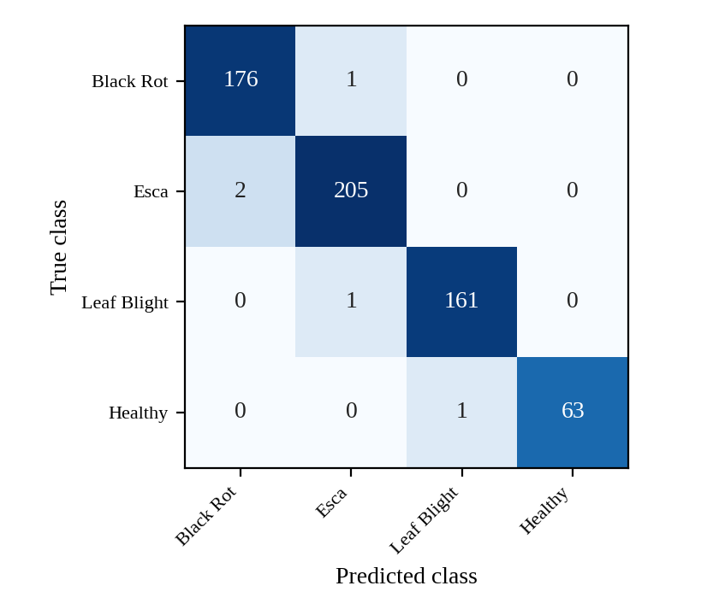
Figure 8: Grapevine confusion matrix (N = 610).
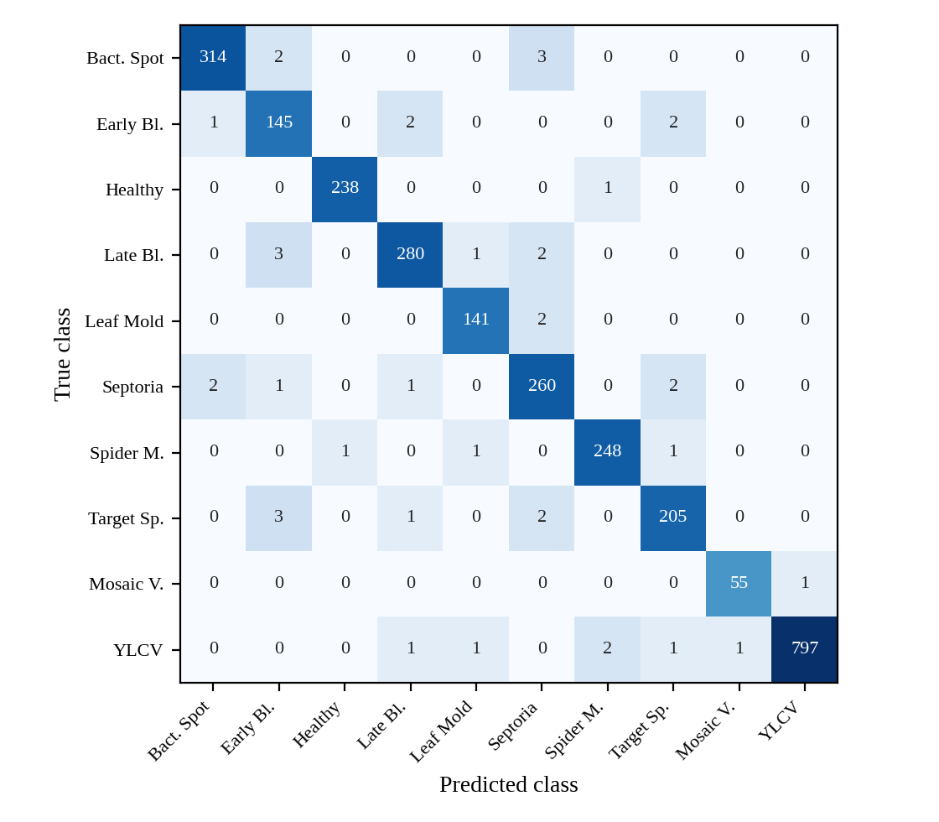
Figure 9: Tomato confusion matrix (N = 2,724). YLCV = Tomato Yellow Leaf Curl Virus.
Diagonal and off-diagonal analysis
Grapevine. The diagonal holds 605 of 610 images (99.18%) and the off-diagonal only 5 (0.82%): Black Rot → Esca (1), Esca → Black Rot (2), Leaf Blight → Esca (1) and Healthy → Leaf Blight (1). Four of the five errors are exchanges among the three diseases, which share necrotic, brown tissue; Esca appears in four of the five. Crucially, no diseased leaf was classified as healthy, so the model produced no false reassurance on the test set. Healthy precision is 100% (every leaf called healthy was healthy) with 98.44% recall.
Tomato. The diagonal holds 2,683 of 2,724 images and the off-diagonal 41 (1.51%). The errors are concentrated, not scattered: 27 of the 41 (65.9%) are confusions among the five lesion-forming classes Bacterial Spot, Early Blight, Late Blight, Septoria Leaf Spot and Target Spot, which present as dark, often ringed foliar spots and are also hard for human scouts to separate. The most frequent single confusions, each with three images, are Bacterial Spot → Septoria, Late Blight → Early Blight and Target Spot → Early Blight. Early Blight has the lowest precision (94.16%) because nine images of other classes were assigned to it (in particular Target Spot and Late Blight), while Septoria also receives nine false positives. By contrast, the systemic viral and mite classes are recognised almost perfectly: Tomato Mosaic Virus has 55 of 56 correct and TYLCV 797 of 803.
Healthy versus diseased screening. Only two of the 41 tomato errors involve the Healthy class (Healthy → Spider Mites and Spider Mites → Healthy). Collapsing all diseases into one class therefore gives a binary healthy/diseased accuracy of 2,722/2,724 = 99.93% for tomato and 609/610 = 99.84% for grapevine, which is the figure most relevant to a first-pass field screening decision.

8.4 Latency, Grad-CAM Overhead and Memory Profile
Table 18 reports single-image (batch size 1) latency of the classifier and of the Grad-CAM explanation, and peak memory, on the three hardware tiers. The total is the sum of inference and Grad-CAM time.
Table 18: Inference latency and memory profile (batch size = 1).
Platform | Inference (ms) | Grad-CAM (ms) | Total (ms) | Throughput (FPS) | Peak memory
Desktop CUDA GPU (NVIDIA RTX) | 11.4 | 4.2 | 15.6 | 64.1 | 1.12 GB VRAM; 385 MB RAM
Desktop CPU (Intel Core i7) | 42.6 | 15.8 | 58.4 | 17.1 | 435 MB RAM
Raspberry Pi 5 (Cortex-A76 @ 2.4 GHz) | 124.8 | 36.5 | 161.3 | 6.2 | 365 MB RAM

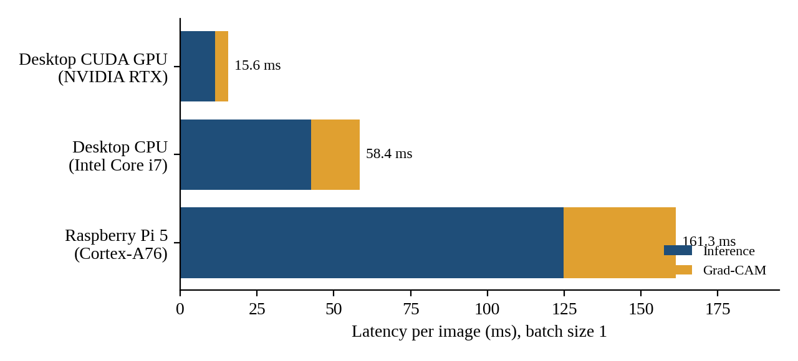
Figure 10: Per-image latency split into classification and Grad-CAM time on three platforms.
Three conclusions follow. (1) Grad-CAM is inexpensive. Because it needs a single forward and a single backward pass, the explanation adds only 4.2 ms (36.8% of inference time) on the GPU, 15.8 ms (37.1%) on the desktop CPU and 36.5 ms (29.2%) on the Pi 5, so every prediction can be accompanied by its heatmap. (2) The Pi 5 is practical. A complete diagnosis with explanation takes 161.3 ms, i.e. 6.2 FPS, which is 2.8× slower than the desktop CPU and 10.3× slower than the GPU, yet comfortably faster than the 200 ms preview timer (5 FPS) used by the application; the interface therefore remains responsive. (3) Memory is modest. Peak RAM is 365–435 MB on CPU platforms, well within the 4 GB and 8 GB variants of the Pi 5, and the 1.12 GB VRAM peak fits any recent GPU.

8.5 Discussion
The principal strength of the system is that each output constrains the others: a prediction is accompanied by a heatmap that can be checked against the visible lesion and by a spectrum in which chlorophyll-related contrast can be inspected, so a user can reject a result that looks right but rests on the wrong evidence. Running on a CPU with a four-million-parameter backbone makes the tool affordable, private and usable without connectivity, and the trilingual interface lowers the language barrier. A single code path for Windows and Raspberry Pi simplifies maintenance.
Three caveats frame the numbers. First, PlantVillage images are laboratory-style with uniform backgrounds and many near-duplicate leaves; the 100% validation accuracy and the 98–99% test accuracy are therefore upper bounds for field performance, as the domain-shift result of Mohanty et al. [3] shows. The perceptual-hash screening of Chapter 3 reduces but cannot eliminate this optimism. Second, the confusions of Section 8.3 are those of human scouts, which supports the view that residual errors come from genuine visual similarity rather than from a modelling flaw. Third, Grad-CAM shows where the network looked, not causal proof of why it decided; hence the human-in-the-loop protocol of Section 5.5.

Chapter 9: Multilingual Knowledge Base and Extensibility

9.1 Trilingual Advisory Framework
A diagnosis is only useful if the grower understands it and can act on it. PlantDiseaseAI therefore couples every class to a structured knowledge entry in English, Hindi and Marathi. Disease names, organic remedies and chemical fungicides were validated against the terminology of the Indian Council of Agricultural Research (ICAR) [31] and Mahatma Phule Krishi Vidyapeeth, Rahuri (MPKV) [32], the state agricultural university of Maharashtra, so that the words shown on screen match those used by extension officers and on agri-input labels. The language can be switched at any time and the text is re-rendered without re-running the model.
Table 19: Trilingual disease names used by the application.
Class | English | हिन्दी (Hindi) | मराठी (Marathi)
Grape | Black Rot | ब्लैक रॉट (काला सड़न) | ब्लॅक रॉट (काळी कूज)
Grape | Esca (Black Measles) | एस्का (ब्लैक मीज़ल्स) | एस्का (ब्लॅक मीझल्स)
Grape | Leaf Blight | पर्ण झुलसा | पानांवरील करपा
Grape / Tomato | Healthy | स्वस्थ | निरोगी
Tomato | Bacterial Spot | जीवाणु धब्बा | जिवाणूजन्य ठिपके
Tomato | Early Blight | अगेती झुलसा | लवकर येणारा करपा
Tomato | Late Blight | पछेती झुलसा | उशिरा येणारा करपा
Tomato | Leaf Mold | पर्ण फफूँद | पानांवरील बुरशी
Tomato | Septoria Leaf Spot | सेप्टोरिया पर्ण धब्बा | सेप्टोरिया पानांवरील ठिपके
Tomato | Spider Mites | मकड़ी कीट (माइट) | कोळी कीड
Tomato | Target Spot | टार्गेट स्पॉट (लक्ष्य धब्बा) | टार्गेट स्पॉट (वर्तुळाकार ठिपके)
Tomato | Tomato Yellow Leaf Curl Virus | टमाटर पीला पर्ण-कुंचन विषाणु | टोमॅटो पिवळा पर्णगुच्छ (लीफ कर्ल) विषाणू
Tomato | Tomato Mosaic Virus | टमाटर मोज़ेक विषाणु | टोमॅटो मोझॅक विषाणू

9.2 Organic versus Chemical Interventions
Each entry separates cultural/organic options from chemical options so the grower can choose according to crop stage, market (for example residue-sensitive export grapes) and organic certification. The organic options are Bordeaux mixture (1%), Trichoderma viride and Neem Seed Kernel Extract (NSKE, 5%); the chemical options are Mancozeb, Difenoconazole, Copper Oxychloride and Metalaxyl. Table 20 gives the trilingual terminology of these agents and Table 21 the indicative mapping used by the knowledge base.
Table 20: Trilingual names of the recommended intervention agents.
Type | English | हिन्दी (Hindi) | मराठी (Marathi)
Organic | Bordeaux mixture 1% | बोर्डो मिश्रण 1% | बोर्डो मिश्रण 1%
Organic | Trichoderma viride | ट्राइकोडर्मा विरिडी | ट्रायकोडर्मा व्हिरिडी
Organic | NSKE 5% (Neem Seed Kernel Extract) | नीम बीज गिरी अर्क 5% | निंबोळी अर्क 5%
Chemical | Mancozeb | मैंकोज़ेब | मॅन्कोझेब
Chemical | Difenoconazole | डाइफेनोकोनाज़ोल | डायफेनोकोनॅझोल
Chemical | Copper Oxychloride | कॉपर ऑक्सीक्लोराइड | कॉपर ऑक्सिक्लोराईड
Chemical | Metalaxyl | मेटालैक्सिल | मेटॅलॅक्सिल

Table 21: Indicative intervention mapping used by the advisory module.
Class | Organic / cultural | Chemical
Grape Black Rot | Remove mummified berries and infected leaves; Bordeaux mixture 1% | Mancozeb; Difenoconazole
Grape Esca | Prune and burn infected wood; protect pruning wounds with Trichoderma viride | No curative foliar fungicide; consult officer
Grape Leaf Blight | Sanitation, canopy ventilation; Bordeaux mixture 1% | Copper Oxychloride; Mancozeb
Tomato Bacterial Spot | Clean seed, crop rotation, avoid overhead irrigation | Copper Oxychloride
Tomato Early Blight | Remove lower infected leaves; Trichoderma viride; Bordeaux 1% | Mancozeb; Difenoconazole
Tomato Late Blight | Destroy infected plants; Bordeaux mixture 1% | Metalaxyl-based combination; Mancozeb; Copper Oxychloride
Tomato Leaf Mold | Improve ventilation, reduce humidity | Mancozeb; Copper Oxychloride
Tomato Septoria Leaf Spot | Remove infected debris; mulching | Mancozeb; Copper Oxychloride; Difenoconazole
Tomato Target Spot | Sanitation, wider spacing | Mancozeb; Difenoconazole
Tomato Spider Mites | NSKE 5%; conserve natural enemies | Registered acaricide on officer’s advice
Tomato TYLCV | Rogue infected plants; control whitefly vector with NSKE 5% and sticky traps | No cure for the virus; vector control only
Tomato Mosaic Virus | Remove infected plants; sanitise tools and hands | No chemical cure
Healthy | Routine monitoring; preventive hygiene | None required

The advisory states agents and concentrations only where the knowledge base specifies them (Bordeaux mixture 1%, NSKE 5%); doses, intervals and pre-harvest periods are deliberately delegated to the product label and the current ICAR/MPKV package of practices, because they depend on crop stage and local registration. Chemical recommendations are accompanied by a prompt to consult an agricultural officer. A sample entry for Tomato Late Blight is:
English: Late blight detected. Remove and destroy infected leaves, improve air circulation, avoid overhead irrigation and consult an agricultural officer for an approved fungicide.
हिन्दी: लेट ब्लाइट के लक्षण पाए गए। संक्रमित पत्तियों को हटाकर नष्ट करें, हवा का संचार बढ़ाएँ, ऊपर से सिंचाई से बचें और अनुमोदित फफूंदनाशक के लिए कृषि अधिकारी से सलाह लें।
मराठी: लेट ब्लाइट आढळला. प्रादुर्भावित पाने काढून नष्ट करा, हवा खेळती ठेवा, वरून पाणी देणे टाळा आणि मान्यताप्राप्त बुरशीनाशकासाठी कृषी अधिकाऱ्यांचा सल्ला घ्या.

9.3 Extensibility
The knowledge base is a data file, not code. Each class identifier maps to a record with one translation per supported language, so adding a language, a crop or a remedy requires no change to the model or the user interface:
{ "tomato_late_blight": {
"name": { "en": "Late Blight", "hi": "<Hindi>", "mr": "<Marathi>" },
"organic": ["bordeaux_1pct"],
"chemical": ["metalaxyl", "mancozeb", "copper_oxychloride"],
"advice": { "en": "...", "hi": "...", "mr": "..." } } }

Missing translations fall back to English so the application never shows an empty panel. The same mechanism supports further regional languages (for example Gujarati or Kannada), and, with a new checkpoint and class list, additional crops.

Chapter 10: Conclusion and Future Scope

10.1 Summary of Contributions and Achievements
This report presented PlantDiseaseAI, an explainable edge-AI and hyperspectral-reconstruction framework for grapevine and tomato disease diagnosis with multilingual advisory. Two EfficientNet-B0 classifiers, trained on deduplicated, stratified PlantVillage data with AdamW, cosine annealing and mixed precision, achieved 99.18% (grapevine, 4 classes) and 98.42% (tomato, 10 classes) test accuracy, with macro-F1 of 99.13% and 98.28%. Grad-CAM on features[-1][0] explains every decision for an additional 4.2–36.5 ms, and the heatmap-review protocol defines how an agronomist distinguishes lesion-focused evidence from background shortcuts. SpectrumTransfer reconstructs 401 bands from RGB using six PCA components and a second-order colour expansion, and shows the expected spectral collapse of infected tissue (670 nm: 8.2% → 27.4%; 750 nm: 53.4% → 24.1%). The whole system runs offline on a desktop and on a Raspberry Pi 5 at 6.2 FPS with 365 MB RAM, exports results to a three-sheet workbook and speaks English, Hindi and Marathi. By making both the where and the which wavelengths of a decision visible, it moves AI-assisted plant diagnosis from a black-box label toward an inspectable aid.

10.2 Limitations
First, the reconstructed spectrum is a statistical estimate learned from data and not a measurement; it should not be used for quantitative biophysical retrieval without validation against a spectroradiometer. Second, PlantVillage images are laboratory-style, so field accuracy is expected to be lower than the reported test scores, and saturated validation accuracy gives no further information. Third, Grad-CAM maps are coarse (7×7 or 8×8 before upsampling) and show relevance rather than causality. Fourth, only one leaf is analysed per image and two crops are supported. Fifth, CPU latency on the Pi 5 limits the live frame rate, and the advisory text is general guidance, not a prescription.

10.3 Future Scope
- UAV multispectral integration. Replacing reconstructed bands with measured bands from a drone-mounted multispectral camera (green, red, red-edge, NIR) would allow field-scale mapping, with the CNN applied to georeferenced tiles and spectral indices such as NDVI_{nb} computed from real reflectance.
- Edge quantisation and NPU acceleration. Post-training or quantisation-aware INT8 conversion would shrink each model from about 16 MB to about 4 MB, and an accelerator alongside the Pi 5 (for example a Hailo-8 at 26 TOPS or a Coral Edge TPU at 4 TOPS) could reduce inference to a few milliseconds; the accuracy loss and the FP32 requirement of gradient-based Grad-CAM would need re-evaluation.
- Mobile field deployment. Exporting the models to ONNX or a mobile runtime would put the classifier and heatmap on smartphones, using the phone camera with an inexpensive clip-on diffuser for illumination control.
- Field-image training and domain adaptation, additional crops and diseases, and a lesion-annotated test subset to report the LOR and BEF heatmap statistics.
- IoT edge nodes that send low-bandwidth results (class, confidence, location) over LoRa or MQTT to a farm dashboard.
- Spectral validation against a reference spectrometer and extension of the advisory to further Indian languages.

References
[1] S. Savary, A. Willocquet, S. J. Pethybridge, P. Esker, N. McRoberts and A. Nelson, "The global burden of pathogens and pests on major food crops," Nat. Ecol. Evol., vol. 3, pp. 430–439, 2019.
[2] D. P. Hughes and M. Salathé, "An open access repository of images on plant health to enable the development of mobile disease diagnostics," arXiv:1511.08060, 2015.
[3] S. P. Mohanty, D. P. Hughes and M. Salathé, "Using deep learning for image-based plant disease detection," Front. Plant Sci., vol. 7, Art. 1419, 2016.
[4] A.-K. Mahlein, "Plant disease detection by imaging sensors," Plant Disease, vol. 100, no. 2, pp. 241–251, 2016.
[5] M. Tan and Q. V. Le, "EfficientNet: Rethinking model scaling for convolutional neural networks," in Proc. ICML, 2019, pp. 6105–6114.
[6] R. R. Selvaraju et al., "Grad-CAM: Visual explanations from deep networks via gradient-based localization," in Proc. ICCV, 2017, pp. 618–626.
[7] A. Krizhevsky, I. Sutskever and G. E. Hinton, "ImageNet classification with deep convolutional neural networks," in Proc. NIPS, 2012, pp. 1097–1105.
[8] K. P. Ferentinos, "Deep learning models for plant disease detection and diagnosis," Comput. Electron. Agric., vol. 145, pp. 311–318, 2018.
[9] E. C. Too, L. Yujian, S. Njuki and L. Yingchun, "A comparative study of fine-tuning deep learning models for plant disease identification," Comput. Electron. Agric., vol. 161, pp. 272–279, 2019.
[10] M. Sandler et al., "MobileNetV2: Inverted residuals and linear bottlenecks," in Proc. CVPR, 2018, pp. 4510–4520.
[11] K. Simonyan, A. Vedaldi and A. Zisserman, "Deep inside convolutional networks: Visualising image classification models and saliency maps," arXiv:1312.6034, 2013.
[12] M. Sundararajan, A. Taly and Q. Yan, "Axiomatic attribution for deep networks," in Proc. ICML, 2017, pp. 3319–3328.
[13] H. Wang et al., "Score-CAM: Score-weighted visual explanations for convolutional neural networks," in Proc. CVPR Workshops, 2020, pp. 24–25.
[14] D. N. H. Horler, M. Dockray and J. Barber, "The red edge of plant leaf reflectance," Int. J. Remote Sens., vol. 4, no. 2, pp. 273–288, 1983.
[15] S. Jacquemoud and F. Baret, "PROSPECT: A model of leaf optical properties spectra," Remote Sens. Environ., vol. 34, no. 2, pp. 75–91, 1990.
[16] B. Arad and O. Ben-Shahar, "Sparse recovery of hyperspectral signal from natural RGB images," in Proc. ECCV, 2016, pp. 19–34.
[17] R. M. H. Nguyen, D. K. Prasad and M. S. Brown, "Training-based spectral reconstruction from a single RGB image," in Proc. ECCV, 2014, pp. 186–201.
[18] Raspberry Pi Ltd, "Raspberry Pi 5 product brief," 2023. [Online]. Available: https://www.raspberrypi.com
[19] J. Deng et al., "ImageNet: A large-scale hierarchical image database," in Proc. CVPR, 2009, pp. 248–255.
[20] J. Hu, L. Shen and G. Sun, "Squeeze-and-excitation networks," in Proc. CVPR, 2018, pp. 7132–7141.
[21] P. Ramachandran, B. Zoph and Q. V. Le, "Searching for activation functions," arXiv:1710.05941, 2017.
[22] I. Loshchilov and F. Hutter, "SGDR: Stochastic gradient descent with warm restarts," in Proc. ICLR, 2017.
[23] I. T. Jolliffe, Principal Component Analysis, 2nd ed. New York, NY, USA: Springer, 2002.
[24] CIE, Colorimetry, 3rd ed., CIE Publication 15:2004, Vienna, Austria, 2004.
[25] S. Süsstrunk, R. Buckley and S. Swen, "Standard RGB color spaces," in Proc. 7th Color Imaging Conf., 1999, pp. 127–134.
[26] A. Paszke et al., "PyTorch: An imperative style, high-performance deep learning library," in Proc. NeurIPS, 2019, pp. 8024–8035.
[27] B. Jacob et al., "Quantization and training of neural networks for efficient integer-arithmetic-only inference," in Proc. CVPR, 2018, pp. 2704–2713.
[28] I. Loshchilov and F. Hutter, "Decoupled weight decay regularization," in Proc. ICLR, 2019.
[29] P. Micikevicius et al., "Mixed precision training," in Proc. ICLR, 2018.
[30] R. Pascanu, T. Mikolov and Y. Bengio, "On the difficulty of training recurrent neural networks," in Proc. ICML, 2013, pp. 1310–1318.
[31] Indian Council of Agricultural Research (ICAR), New Delhi, India. [Online]. Available: https://icar.org.in
[32] Mahatma Phule Krishi Vidyapeeth (MPKV), Rahuri, Maharashtra, India. [Online]. Available: https://www.mpkv.ac.in

